HORSHAM BLUE STAR HARRIERS KIT

The online shop is currently not available but items can still be purchased.
A selection of club kit including waterproof jackets, t-shirts and hats can be bought by sending your order to Miranda Huisman at mmbhuisman@outlook.com
Payment can be made by cheque to the club treasurer or BACS.
BACS payments should be made to Account name Horsham Blue Star Harriers, Account number 01303473 Sort code 40-24-33 Please put “kit “and child’s surname as the reference.
All items carry the Horsham Blue Star Harriers club logo and can additionally be printed with your name or initials at your request.

Short sleeve t-shirt

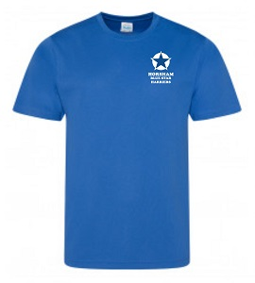

 | Size | Price
Men | XS,S,M,L,XL,XXL | £16.96
Women | 8,10,12,14,16,18 | £16.96
Children | Age 3-4 to 12-13 | £13.78

Comes complete with optional name or initials on the right breast & printed back logo.

Long sleeve t-shirt

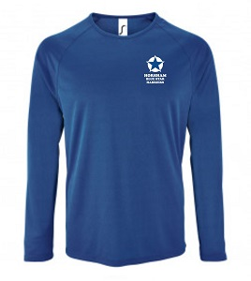

Long sleeve t-shirt | Size | Price
Men | S,M,L,XL,XXL | £17.12
Women | 8-10 to 16-18 | £17.12

Comes complete with optional name or initials on the right breast & printed back logo.

Showerproof Jacket
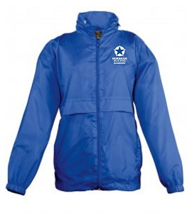
Showerproof Jacket | Size | Price
Unisex adult | XS,S,M,L,XL,XXL | £23.42
Children | Age 5-6 to 15-16 | £19.52
Comes with optional name or initials on the right breast & printed back logo.

Beanie

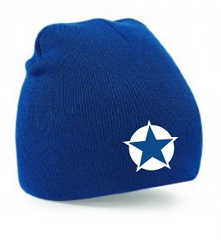
Beanie | Size | Price
Adult | one size | £6.54
Children | one size | £5.52

Waterproof Jacket

Waterproof Jacket | Size | Price
Men | S,M,L,XL,XXL, XXL | £60.64
Women | 8 to 16 | £56.52

Comes complete with printed HBS logo on left breast with optional name or initials on the right breast & printed back logo.

Hoodies

Hoodies (£16.00) are available for purchase on training nights at the track. Please speak to Miranda or Elspeth Turner.

